Intinta Innovator Award – 2019
Mr. Alankar, III year Mechanical Engineering student of HITAM was awarded best innovator award from Telangana for his creation Solar Powered Pool Skimmer by the State at Confederation of Indian Industry Man 'Exe event that took place on the 18th of Oct. The award was presented by the Hon. Minister KT Rama Rao and Principal Secretary Jayesh Ranjan
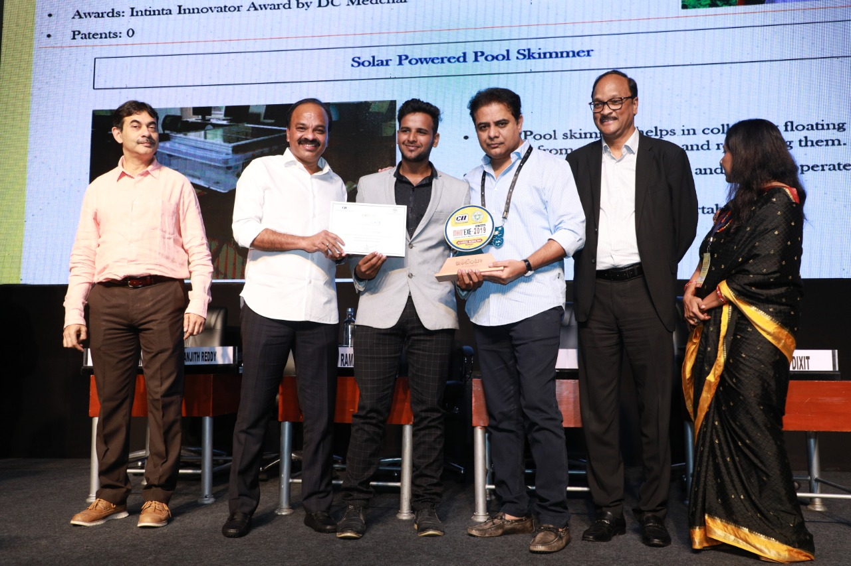
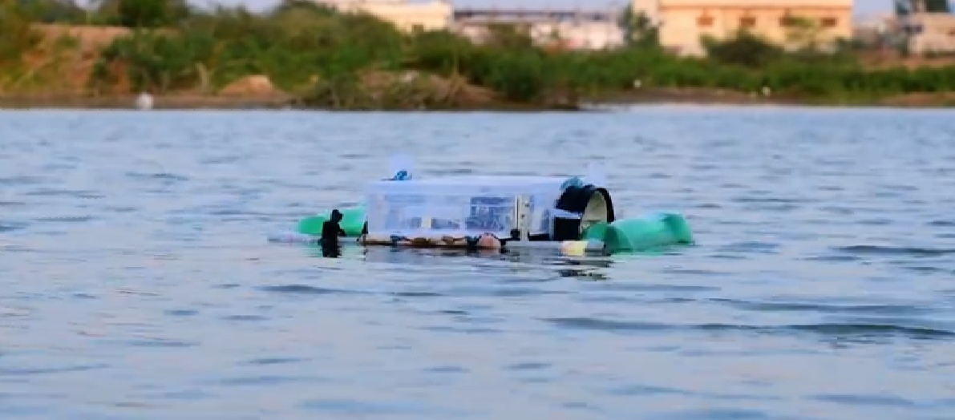
Our Community Partner Mr. RamuGoud staying in D Pochampally village. They have a lake in their village which is ill maintained, people find it difficult to clean the lake, due to its depth. He wishes for a machine which can clean the lake without risking life of anyone during its cleaning.
• Farmers are facing problems to remove stones in the field which they need to get removed before cultivating the fields. Its time consuming and a herculean task for them.
• We as a team decided to provide a solution for our community partner by which he can do his work easily and efficiently. Therefore, we have come up with an idea of making solar pool skimmer which can be operated from any remote place. After considering the consumption of electricity in the existing product, we have decided to make this solar pool skimmer a complete environment friendly product

Intinta Innovator Award – 2020
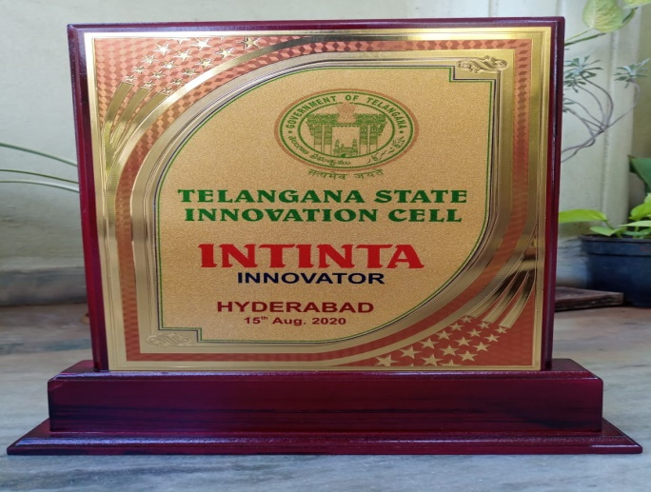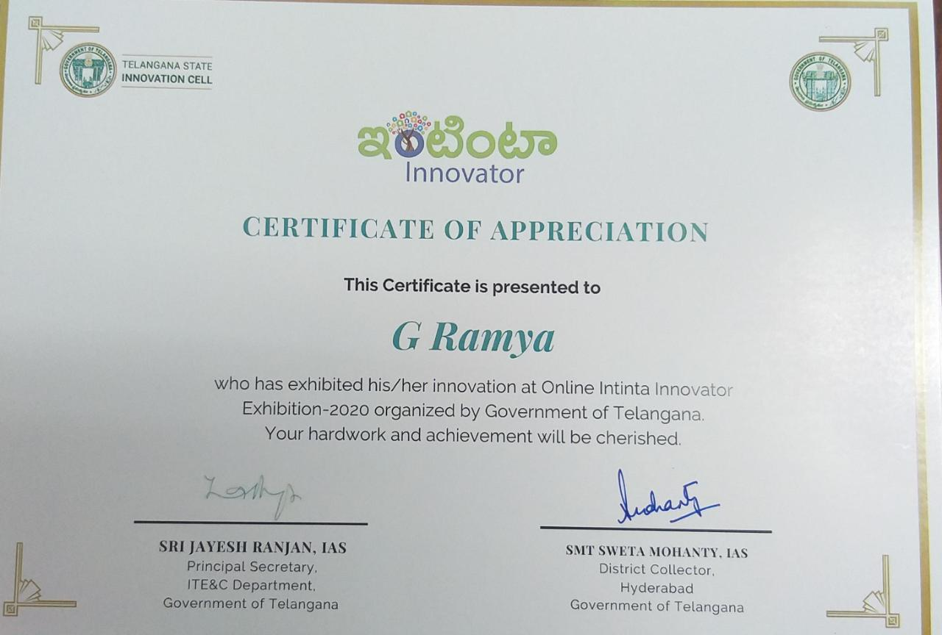
Our community (Mr. Narasimha Reddy) is a farmer who stay’s at Gnanapoor village, Telangana. He is a farmer by profession and also maintains a low level dairy farm. His primary work in dairy farm is to clean the excreta and other kinds of waste from the dairy farm. Due to conventional methods he is facing medical issues and also wasting the excreta of the cow and buffalo. On interaction with him we came to know that he is willing to get a machine/ device which helps him in cleaning the dairy farm.
Our solution will provide best device which will reduce the human effort and difficulties while cleaning the excreta and other waste from the dairy farm. While dealing with new technology machines, we are generally neglecting electricity consumption by machines and other basic factors such as safety, cost and maintenance. Our main concern while designing this product is capital, risk to cattle by device and vice versa. Therefore our product will minimize these sorts of problems.

